**Spring MVC Example**

Spring MVC is based on Model-View-Controller architecture. Below image shows Spring MVC architecture at a high level.

[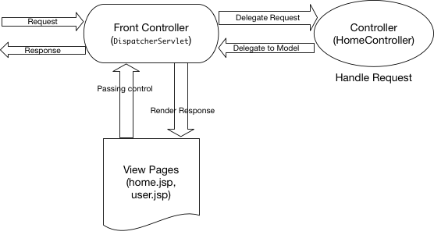](https://cdn.journaldev.com/wp-content/uploads/2017/07/spring-mvc-architecture.png)

DispatcherServlet is the front controller class to take all requests and start processing them. We have to configure it in web.xml file. It’s job is to pass request to appropriate controller class and send the response back when view pages have rendered the response page.

HomeController.java will be the single controller class in our spring mvc example application.

home.jsp, user.jsp are the view pages in our spring mvc hello world example application.